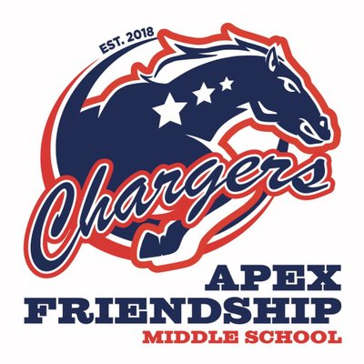

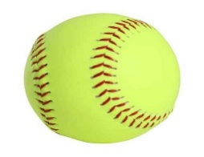
This Photo by Unknown Author is licensed under CC BY-NC-ND
This Photo by Unknown Author is licensed under CC BY-NC-ND
2020 Apex Friendship Softball Roster

# | Name | Position | Year
1 | Brianna Spero | Utility | 7
2 | Maeli Johnson | IF/OF | 7
3 | Taylor Wachter | IF/OF | 8
4 | Lena Salerno | OF | 8
5 | *Kara Thomas | IF/OF | 8
6 | Kayla Delitizia | IF/OF | 8
7 | Jocelyn Burkhardt | C | 7
8 | Paige Frasz | IF/OF | 7
9 | *Sydney Joyce | Utility | 7
10 | Hannah Rooney | Utility | 7
11 | Sadie Puckett | Utility | 7
12 | Santhoshini Radhakrishnan | Utility | 7
13 | Skye Zenni | Utility | 7
14 | Brooke Koester | Utility | 7
15 | McKenna Hartman | Utility | 7
16 | Mikaylen Robinson | Utility | 7
17 | Juliana Cascino | Utility | 7
*-Team Captain
Coaches: Mike McColgan
CJ Salvador
Managers:
Kylie McGrogan Alia Beck Addison Delitizia
Emma Johnson Lilly Kell

