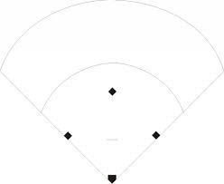

AFMS Softball

Catcher 2

Bunt Coverage Runner on 1st & 3rd

Pitcher 1

First Base 3

Second Base 4

Short Stop 6

Third Base 5

Left Field 7

Center Field 8

Right Field 9

Left Field 7