AFMS Curriculum Assistance Syllabus – Fall Semester 2019

I have read and understand the policies and procedures for Curriculum Assistance.

Student Name (print):_________________________________________ Date__________________

Student Signature:_____________________________________________ Date__________________

Please include the following information:

Parent(s) Name:_____________________________________________________________________

Parent Contact Numbers:___________________________________________________________

Parent E-mail:________________________________________________________________________

Parent Signature:___________________________________________________________________

Course Description

CA is a time where students will be working in IEP goals. We will together monitor the progress of each goal, which will help with core class understanding. Each CA class may have a 15-20 minute whole group lesson revolving around Reading, Writing or School Survival Skills. The class is to work on IEP goals and might have content remediation as part of the IEP goal monitoring process. Through the class students will also be exposed to test taking strategies/skills, organizational skills, Classroom behavior skills. The class will be graded on a Pass/Fail basis.

GRADING POLICY
Curriculum Assistance (CA)
Fall 2019 8th Grade
APEX FRIENDSHIP MIDDLE SCHOOL
ROOM 2208
Mr. McColgan
Email: mmccolgan@wcpss.net
Office: Rm. 2208
Website: mmccolgan.weebly.com

CA Class

*15-20 Minute CA Lesson
Reading, Writing, School Survival Skills

*20-25 Minute IEP Goal
Monitoring.

SUPPLIES

Binder
Notebook paper
Dividers/Tabs
Colored Pens
Highlighters

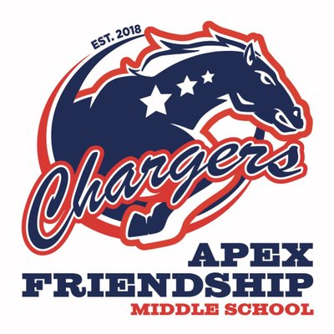
EXPECTATIONS

Engaged

Respectful

Self Improvement

No Electronics

CA will be graded on a Pass/Fail Basis
Semester Grades
Quarter 1: 50%
Quarter 2: 50%

Quarter Grades
IEP Goal Skills: 50%
CA Engagement: 50%

