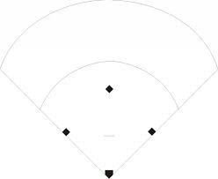

AFMS Softball

First Base 3

Pitcher 1

Short Stop 6

Third Base 5

Second Base 4

Cut off Responsibility

Ball hit to Center Field

Catcher 2

Left Field 7

Center Field 8

Right Field 9

Left Field 7