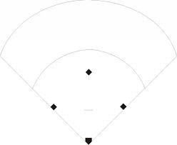

AFMS Softball

Pitcher 1

Third Base 5

First Base 3

Second Base 4

Short Stop 6

Cut off Responsibility

Ball hit to Left Field

Catcher 2

Left Field 7

Center Field 8

Right Field 9

Left Field 7