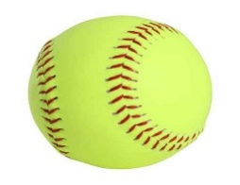
This Photo by Unknown Author is licensed under CC BY-NC-ND
This Photo by Unknown Author is licensed under CC BY-NC-ND

2019 AFMS Softball
Tryout Evaluation

Date:
Criteria: 5-Exceptional 4-Good 3-Average 2-Needs Work 1-Not Seen
Player | Grade | Position | Home-1st | Home-2nd | Throwing | Hitting | Intangibles
Davis, Faith | 8 | 3

Criteria: 5-Exceptional 4-Good 3-Average 2-Needs Work 1-Not Seen

Player | Grade | Position | Home-1st | Home-2nd | Throwing | Hitting | Intangibles

